ECE5520 / ECE4520 Automotive Mechatronics I

Arduino UNO Q-Based Sensor Fusion Collision Avoidance System for an RC Vehicle
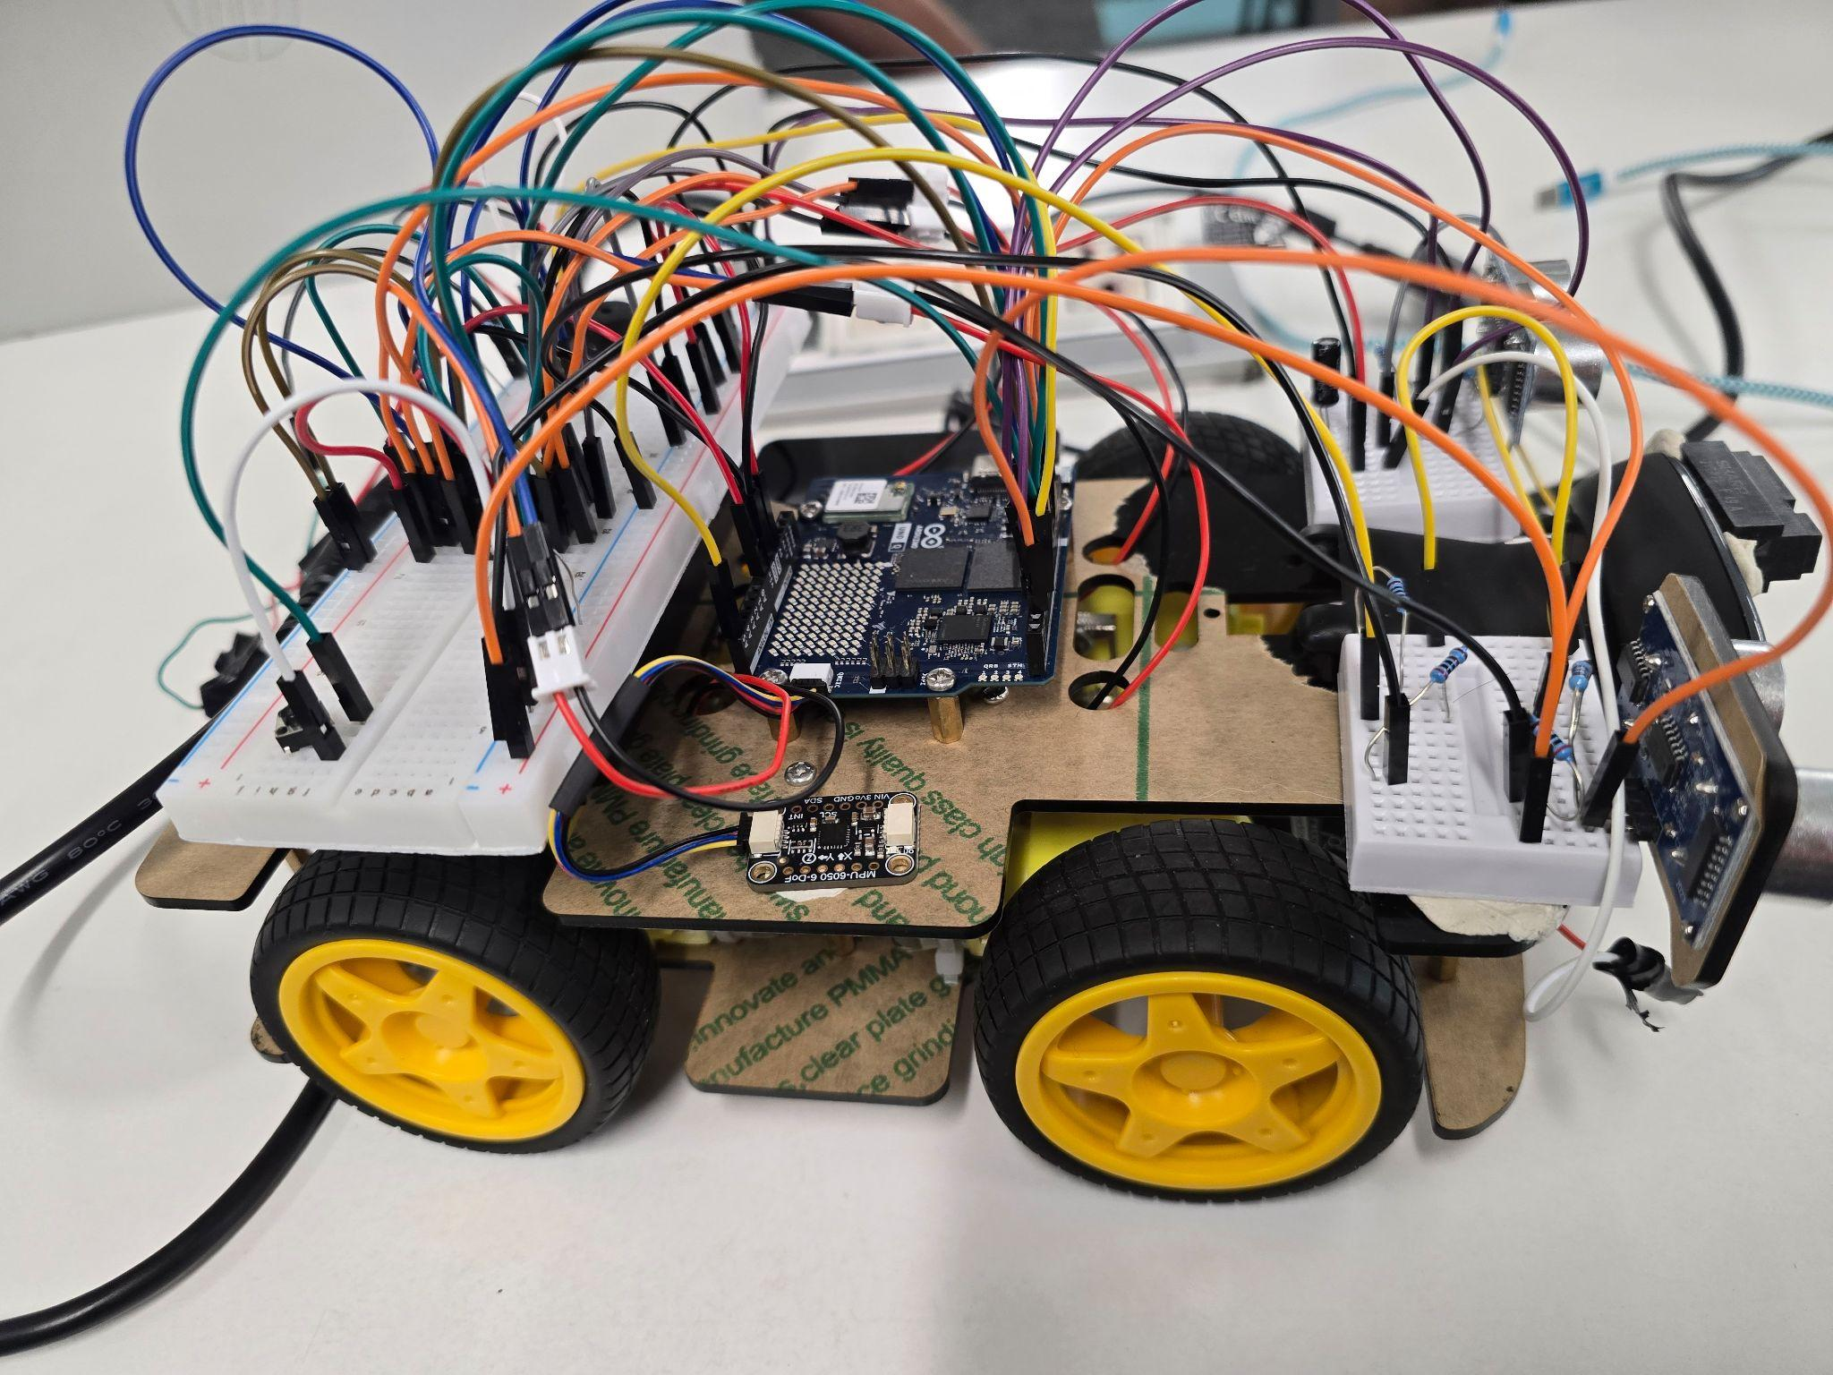

Team Members:

Sergio Gamez Jr
G00928072
sgamez@oakland.edu

Narsai Ibrahim
G00910816
nibrahim3@oakland.edu

Connor Sitarski
G00847826
cjsitarski@oakland.edu

Submitted To:
Dr. Nashwan J. Sebi

Introduction

In the modern day, automotive safety systems rarely rely on a single sensor signal to make critical decisions. Nowadays, there are radars, cameras, lidar, and inertial data that have their data fused and processed to prevent blind spots or failures that can occur in the vehicle This project demonstrates a small-scale collision avoidance system using an RC vehicle that fuses ultrasonic, infrared, inertial, and camera measurements into a single obstacle distance. Relying on any one sensor leads to risks of false alarms or missed detections. To resolve these issues, a Kalman filter is implemented so that all 4 sensor inputs are weighted by reliability into one real time distance and velocity estimate.

Motivation and Problem Definition
Automotive Safety Systems usually never rely on one sensor. Most sensors are noisy and introduce uncertainties. Instead, they combine several imperfect measurements into one coherent estimate. This project builds a small-scale version of that idea on real hardware, with real electrical and timing constraints. The goal of this project wasn't just to stop the car when one sensor sees something close; that's easy. The main goal was to fuse multiple sensor data readings with different reliability levels into a single reliable estimate. In other words, take several noisy, asynchronous distance sensors and turn them into a single, reliable, real-time distance and speed estimate, which is fast enough to stop the car before a collision. The ultrasonic sensors, IR sensor, and camera each measure distance differently, with different error patterns.

A Kalman filter lets the system weigh each one by how much it's trusted, instead of just averaging them. The system needs a fast 50Hz sensor loop for safety, but the camera’s object detection is much slower. This must not interfere with the faster sensor path. If a drive command conflicts with a stop condition, safety wins. A STOP alert blocks forward motion. Since the MCU and Linux side are separate, they need a reliable way to talk, fast sensor data one way, safety commands the other way. Given a six-week timeline, the scope was kept to getting ultrasonic + IR + IMU fusion working reliably on the fast loop and adding the camera as a slower supporting input while building and showcasing a live dashboard for demos.

Hardware / Electrical Design

The vehicle is a Freenove 4WD chassis powered by a 7.4V LiPo battery. The controller is an Arduino UNO Q 4GB, which has an STM32U585 microcontroller and a Qualcomm QRB2210 Linux processor on one board, linked internally by an RPC bridge. Here is our sensor/hardware stack:
Sensor | Interface | Purpose
HC-SR04 Ultrasonic (×2) | Digital (Trig/Echo) | Primary distance measurement, front-left and front-right
Sharp GP2Y0A21 IR | Analog | Secondary short-range distance measurement
MPU-6050 IMU | I2C (Qwiic/STEMMA QT) | Vehicle acceleration for the Kalman filter's motion model
Logitech C270 Webcam | USB | Camera input for object-detection distance estimate

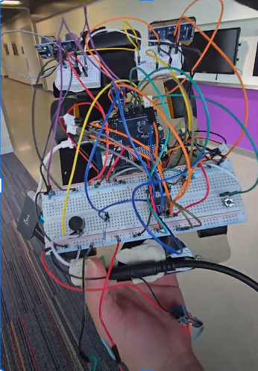
Figure 1:Final Hardware setup

The HC-SR04 echo pins output 5V, and the Sharp IR sensor can output up to about 3.1V; both are too high for the UNO Q's 3.3V-max inputs. A 1kΩ resistor in series with a 2kΩ resistor voltage divider brings each signal down to a safe level. A 100nF capacitor on the IR signal helps filter out noise. Two L293D H-bridges drive the four DC motors. The enable pins also have 10kΩ pull-down resistors connected to ground. Without the pulldown resistors, those pins float during boot and can read as "on," spinning the motors up before the firmware even starts. The pull-downs force a safe default without affecting normal PWM control once the code is running. Power is split to keep the noisy motor circuit isolated from the sensitive sensor and logic circuit: Raw 7.4V from the battery powers the motors directly and the UNO Q's VIN pin. Arduino 5V pin powers the sensors and the L293D’s logic pins. The USB camera hub gets its own power from a USB-C PD trigger board, also fed from the battery; needed due to a UNO Q hardware limitation. A push button toggles the motors on and off for testing, and a piezo buzzer beeps faster as the alert level increases, using non-blocking timing to avoid interfering with the sensor loop.

Software Design
The software runs across both processors, connected by the UNO Q's built-in Bridge. The MCU handles reading all four sensors every 20ms (50Hz) and setting motor output based on the latest command and safety alert. The Linux side handles everything else: the Kalman filter, the camera pipeline, and the dashboard. The Kalman filter tracks two values: distance and closing velocity. Every time a sensor packet arrives, it predicts the new state using the IMU's acceleration reading, then updates that estimate using each valid sensor reading. Each sensor gets a trust weight R. A lower R value means the sensor is more trusted. The camera estimates distance from the size of the detected object's bounding box, using a calibrated formula, and feeds into the same filter as a fourth, slower, best-effort input. Time-to-collision is simply distance divided by velocity. That value maps to four alert levels: CLEAR, WARNING, SLOW DOWN, STOP. The MCU tracks two things: whether forward drive is currently commanded, and the current alert level from the Linux side. Whenever either value changes, arbitration logic recalculates motor output using a few simple rules. A STOP alert blocks forward motion entirely, while a SLOW DOWN alert reduces speed without blocking it. If there's no active drive command, the motors default to stopped.

The vehicle was programmed to drive forward only, with the Linux side's alert level acting as the sole override on that motion. The camera pipeline uses the YOLOv5n computer vision model and runs through OpenCV's DNN module on the CPU. Since inference takes tens of milliseconds, it runs on its own thread so it never blocks the camera feed or the sensor loop. A dedicated camera thread continuously grabs only the latest frame, discarding stale ones so processing never falls behind. A separate inference thread consumes the currently available frame, runs detection, and filters the results. The main loop then reads the latest frame and the latest detection independently, rendering bounding boxes and serving the live video stream without ever waiting on the inference thread directly. Finally, A Flask dashboard runs on the Linux side, showing a live video stream with detection bounding boxes overlaid, real-time distance, closing velocity, and TTC readouts, and a color-coded alert-level indicator. It updates through lightweight JavaScript polling, so it stays responsive regardless of video frame rate.

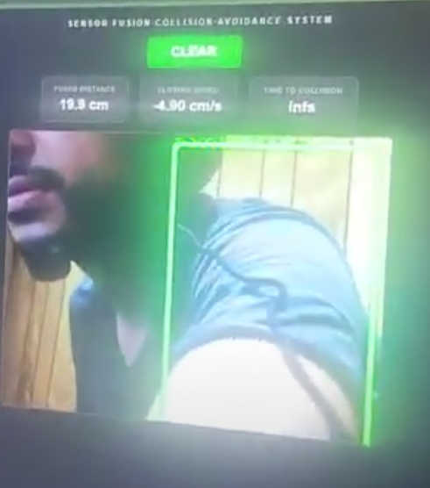
Figure 2: Sensor Fusion Dashboard

Challenges
- The UNO Q’s USB-C port doesn't power connected devices the way most host ports do. It expects a self-powered hub. This wasn't obvious and caused a lot of "device not detected" confusion before we found the actual cause. The fix was a powered hub with its own battery-fed power source, independent of the board.
- A software update mid-project, combined with a disconnected cable, forced a full board reflash, wiping the Linux filesystem, including earlier fixes and files that weren't backed up elsewhere. Lesson learned: back up code and models outside the board.
- The UNO Q's USB-C port can boot into device mode instead of host mode when powered by battery, which stops any USB device, including the camera, from being recognized. A community fix forces host mode at boot, but it didn't always survive a board reflash.
- The board's WiFi capabilities did not work when working with the university WiFi. This means that when programming the board on campus, reflashing had to be done via USB-C instead of WiFi. Ultimately, this made debugging cumbersome since the camera had to be unplugged and replugged every time.

Conclusion
This project successfully demonstrated a working sensor fusion collision avoidance system on a small-scale RC vehicle, ultimately achieving the goal of combining four asynchronous sensors, including (dual ultrasonic, IR, IMU sensors and a web camera) into a single control system that determines distance and velocity using a Kalman filter. This was achieved by splitting the responsibilities of the UNO Q’s dual processors. Given the six-week timeline, the team was able to accomplish getting the ultrasonic,IR,and IMU fusion working reliably before integrating the camera as an additional input that improved accuracy when working properly. Future work could be implemented like expanding the vehicles motion beyond just forward only driving while also improving the camera base distance under variation in light and objects.Overall, this project demonstrates that meaningful improvements in reliability and safety don't require expensive or exotic hardware.

